Ideation Phase
Empathize & Discover

Date | 20 Feb 2026
Team ID | LTVIP2026TMIDS79198
Project Name | Resolve Now- Your platform for online complaints
Maximum Marks | 4 Marks

Empathy Map Canvas
An empathy map is a simple and effective visual tool used to understand users’ behaviours, needs, experiences, and emotions while interacting with a system. It helps development teams gain deeper insight into user expectations before designing a solution. Creating an empathy map allows developers to think from the user’s perspective by analyzing what users say, think, do, and feel when facing a particular problem. Understanding these aspects helps in identifying real-world challenges and designing user-centered applications. For the Complaint Registry System, empathy mapping helps analyze the difficulties users face while submitting complaints and tracking their resolution through traditional methods.
Reference: https://www.mural.co/templates/empathy-map-canvas
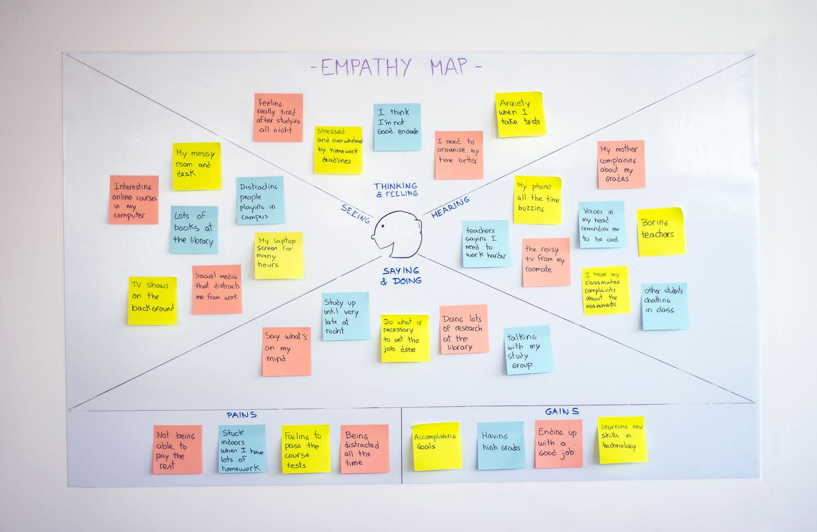

User Understanding Through Empathy Mapping
The empathy mapping process helps identify how users interact with complaint systems and what challenges they experience. Users often express dissatisfaction due to delays in complaint resolution and lack of communication. They expect a simple and reliable online platform where complaints can be submitted quickly and tracked easily. Users generally think that manual systems are slow and inefficient, and they prefer digital solutions that save time and effort. In real situations, users repeatedly visit offices, contact support services multiple times, or search online platforms to resolve their issues. These experiences often make users feel frustrated, confused, and ignored when updates are not provided. However, users feel satisfied and confident when they receive timely responses and transparent status updates.
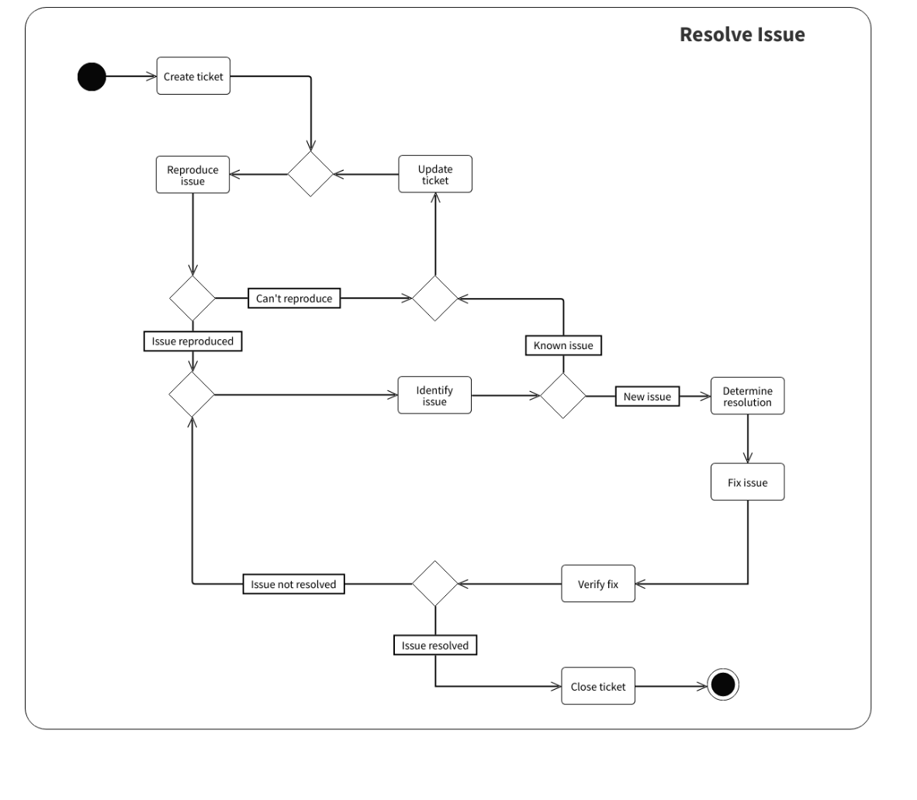

Proposed Solution
The Complaint Registry System addresses these challenges by providing a centralized digital platform for complaint management. The system allows users to register complaints online, securely log in to their accounts, and track complaint progress in real time. Administrators can manage complaints through a dashboard, update statuses, and communicate with users effectively. This digital approach reduces manual work, improves transparency, and ensures faster complaint resolution.

Outcome of Empathy Mapping
The empathy mapping activity helped in clearly understanding user expectations, emotions, and challenges. Based on these insights, the system was designed to provide a user-friendly interface, improved communication, and efficient complaint handling. The final solution aims to enhance user satisfaction, reduce processing time, and create a transparent complaint management process that benefits both users and administrators.

